University of Sunderland
Role profile

Job title:
Exhibitions Coordinator

Grade:

D

Department:
School of Media and Creative Industries

Location:
University Gallery at Culture House (Northern Gallery for Contemporary Art)

Reports to:
Faculty Operations Manager

Working hours:
37
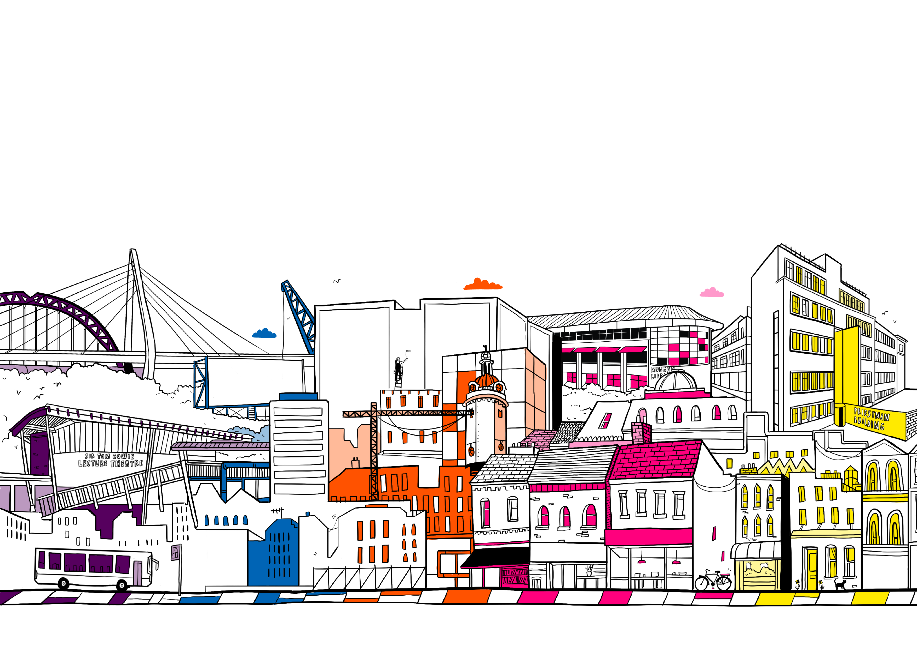

The role:
As Exhibitions Coordinator you'll play a pivotal role in supporting the effective delivery of exhibition programmes and ensuring that the University Gallery at Culture House is operationally fit for purpose and open to public 7 days per week. The role will involve exhibition production, gallery operations, collection and archives management, administration and student and visitor engagement support.

The responsibilities:

Exhibition Production

- Contribute to programme development to ensure ideas are operationally and technically viable
- Work with NGCA Curator (and other exhibitions leads) to develop technical installation plans for all exhibitions, including technical staffing capacity (including freelance) and equipment hire
- Lead on installing all exhibitions both on site and off site (including collections displays off site)
- To be responsible for art handling procedures for all exhibits. Processing and documenting the condition on arrival of all artwork, handling, installation, monitoring and safeguarding of all artwork during exhibition, touring and transit.
- To maintain, monitor exhibition spaces, advise on and source specialist exhibition equipment when needed with the assistance of other technical colleagues.
- To assist in the production and editing of text for exhibition interpretation, programme information publications, printed materials and website.

Gallery Operations

- Ensure gallery is operationally fit for purpose and open to public 7 days per week (unless during exhibition changeover)
- Liaison with key colleagues in the university, Culture House and Sunderland Culture around gallery operations, communication and protocols to ensure the gallery is operationally fit for purpose and open
- Development of risk assessments, management and maintenance responsibility for equipment and furnishings
- Line management/supervision of gallery staff and volunteers for 7 day per week operation
- Monitor and cover GLF holiday and sickness
- Maintain records of visitor numbers and feedback via the gallery staff team

NGCA Collection and archives Management

- Develop loan of NGCA collection packages and protocols including insurance, budgets, scheduling, safe installation and transport
- Maintain and monitor NGCA collection and provide access where required
- To support collection management and development work, and help to document, order and present the collection.
- Contribute to the development and safe keeping of the NGCA archives.

Administration

- Develop, maintain and monitor schedules for installation of exhibitions and loans
- Other administrative duties including booking of travel, accommodation, and dealing with expenses for artists and others involved in installs
- Developing and maintaining artwork condition reports with the curator

Student and visitor engagement support

- Demonstrate aspects of exhibition production to students
- Support the organization, scheduling and delivery of outreach and engagement opportunities - for example student events, young people’s art clubs, school events, art nights, workshops.
- Liaison with internal colleagues and external stakeholders to support the programme, events and engagement

Other duties

- Internal and external communications with colleagues and stakeholders to plan installation of exhibitions and loans
- To work as part of technical support project teams as/when required.
- To undertake any other such duties commensurate with the role as required from time to time

Special circumstances:
At times the role may require working 5 days over a 7 day period. This requires a flexible approach to work which may incorporate some evening and weekend working if appropriate.

Annual leave may also be restricted at certain times of the year to account for peaks in workload. May include occasional work across the university, Culture House and other external venues by agreement.

The benefits:
At The University of Sunderland, we are committed to creating a work environment where you can truly thrive. We recognise that our success is built on the dedication and talent of our people, which is why we have developed a benefits package designed to support you in every aspect of your life.

From generous annual leave and enhanced pay for important life events like maternity, paternity, or adoption, to flexible work options that help you balance life’s demands, we’ve got you covered. Our benefits also include access to our award-winning staff support networks, confidential employee assistance, discounts on major retail brands, leisure activities, travel to work, and more.

At Sunderland, we’re not just offering a job, we’re offering a place where you can grow, connect, and feel truly valued.

Who we’re looking for

Your qualifications include:

- Educated to Degree level or equivalent within a related subject area. (Essential)
- Post graduate qualification within a related subject area. (desirable)

Your experience includes:

- Practical experience of handling art. (Essential)
- Demonstrable experience of working within a similar visual arts focused role. (Essential)
- Proven experience of project, event and exhibition coordination (Essential)
- Good proven knowledge of visual art. (Essential)
- Demonstrable IT skills in wide variety of Microsoft Office packages. (Essential)
- Excellent administration, planning and organisational skills. (Essential)
- Excellent communication skills – written, verbal and visual (Essential)
- Well networked in the visual arts community. (desirable)
- Understanding of the needs of a Higher Education environment (desirable)

Your expertise includes:

- Working Collaboratively: Demonstrating honesty, loyalty, integrity, creativity and flexibility
- Accountability: Taking ownership and displaying resolve to be accountable for delivering against objectives
- Strong communication and interpersonal skills: Demonstrating the confidence to build relationships and engage effectively and positively across a range of stakeholders both internal and external to the University.
- Productivity and proactiveness: Being able to demonstrate a 'can do' approach
- Being culturally aware, accepting and embracing different cultures, and demonstrating a high level of commitment to equality, diversity, and inclusivity.



Culture Framework:
Our Culture Framework presents the way we do things at the University of Sunderland. It is a living document of our culture. It supports how we apply ourselves at work and it helps with our approach to making decisions and working with each other.

It is woven into all our people policies and procedures, supporting how colleagues are managed, recognised, and developed. Our values are our shared principles as an institution. We undertake actions to make them come to life. If you decide that a career with us is perfect for you, then these principles will lead and motivate your work every single day.


INCLUSIVE
We celebrate our diverse culture where everyone's contribution is welcomed and valued.

What role models do:
RESPECTFUL - Understand differences & respect Individuality
AUTHENTIC - Strive for honest & genuine interactions
DIVERSITY CHAMPIONS - Invite & listen to the views & opinions of others


INSPIRING
We will provide an inspiring, enterprising, and empowering experience for our students and staff.

What role models do:
ENTHUSIASTIC - Bring pride to the work we do, championing the work of others and our University
ENCOURAGING - Motivate & support others through meaningful feedback
LIFE-LONG LEARNERS - Continually seek opportunities to develop & share learning with others


INNOVATIVE
We value people for their creativity and update our knowledge and practice to enhance the student experience and improve our institutional performance.

What role models do:
CREATIVE - Look inside & outside of the University for inspiration
CURIOUS - Open to ideas, asking questions & challenging respectfully
SOLUTIONS FINDERS - Look for ways to continually improve & taking risks to make it happen


COLLABORATIVE
We work together as a community with our partners and build lasting relationships to achieve our shared ambition.

What role models do:
ACCOUNTABLE - Take ownership of our own work and our impact on others
COMMITTED - Share information and knowledge with others
RELATIONSHIP BUILDERS - Work effectively in our own teams but also involve others outside of our immediate teams or the University


EXCELLENT
We strive for EXCELLENCE in all that we do in teaching, learning, research and knowledge exchange, as well as in the services we provide to students and to each other.
To enable us to be excellent, we seek to act in ways that are INCLUSIVE, INSPIRING, INNOVATIVE & COLLABORATIVE.

